- Reopening Arvalee: 1st September 2020
One of the following Plans will be applied in August according to updated advice in July and August. Currently we are considering Plan A.

PLAN A:
 | MON | TUES | WED | THURS | FRI
31 August – 4 Sept | BANK HOLIDAY | All pupils to Return: Some pupils may require transition support back into School or additional guidance from Health

The school has created Bubbles/Sections in line with the PHA advice regarding the spread of Covid 19 and has encouraged the increase of hand washing, the use of hand sanitiser, social distancing when possible and sanitation practice.

- General Principles within all Plans:
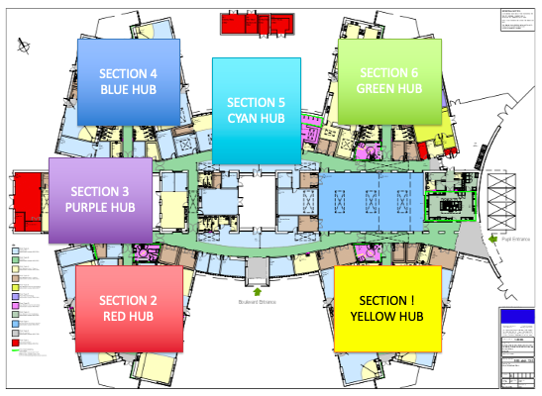
Sections/Bubbles

Your child will be taught in one of the sections and the School plans to use this structure to limit contact and ensure best practice in Cross infection.

- Attendance
3.a Temperatures:
- Pupil’s temperatures are not to be taken unless the individual presents with symptoms of feeling unwell. Adults will take their own temperature and monitor their own health.

3.b Under no circumstances should pupils or staff attend school if they:
- feel unwell, have any of the three identified COVID-19 symptoms (a new continuous cough, a high temperature or loss of taste or smell) or they have tested positive to COVID-19 in the past 14 days.
- live in a household with someone who has symptoms of COVID-19 or has tested positive to COVID-19 in the past 14 days.

If you feel your child cannot attend school contact the school and we will work to support your child.

- Guidance Points
- Hand washing and Social distancing for adults are the main thrust of the PHA guidance coming to schools but we will continue to apply the guidance as we move forward.

- All staff are to enter via the front door of the school and take their own temperature and record it. If it is high do not enter the building, phone the school and inform of your absence due to illness. An adult temperature needs to be below 37.7. The temperature should be taken three times to ensure that it is high. If the Temperature is high the staff member must return home immediately and contact the school to advise them of the illness. If the temperature returns to normal, a return to work is appropriate and the staff member is to contact the school.

- The School will only have essential visitors. All visitors must report to the front door at reception. No access will be facilitated at the side Pupil entrance. This is to ensure that temperatures are taken and hands are sanitised prior to entry to the building.

- Pupils are not to wear PPE. Frequent handwashing will be encouraged in each classroom. The minister announced that Face Masks should be worn by Post Primary aged pupils. The school will support the pupils that want to and can wear a mask when moving around the school. Masks are not compulsory for pupils. Staff will be in face coverings/shields in the corridors but not in their Bubble/Section.

- Where pupils can social distance this is to be encouraged and supported. Pupils should be seated 1 metre apart and lining up should reflect social distancing regulations. If possible, staff can maintain a 2 metre distance but this will be considered with each child and classroom as appropriate to the child’s care, understanding and development needs. Social Distancing is encouraged in the bubbles but not compulsory.

- In the sections, due to the guidance regarding the 15 minute exposure time to Covid 19, staff will not wear PPE other than in situations where this guidance cannot be maintained and during intimate care procedures. Where this PPE cannot be worn due to the child’s behaviour or the child’s understanding of the situation the staff are to ensure frequent handwashing. Each Care and Behaviour Plan must be considered in light of Social Distancing and how learning can be facilitated without a challenge that may lead to the requirement for prolonged periods of contact.

- If the pupil presents with symptoms of Covid 19, the pupil will be taken to the Learning Support Room and await the parent to pick the child up. The Temperature will be taken to indicate if it is high. This should be done three times to ensure a high reading. Staff should wear PPE as recommended by the PHA and ensure consistent hand washing.

- Medication must be in a clearly marked bottle with a prescribed label. Unless it is part of the Care Plan all medication will be kept in School. The current policy for administration of medication and storage will continue to apply.

- If your child requires changes of clothes and/or nappies, they are too be sent into his/her class in a bag clearly marked with your child’s name.

- Dinner Money needs to be in a sealed envelope and clearly marked with your child’s name. The School would ask that the right money is used as the school cannot give change at this time.

- The Pupils lunches will be served in their Bubbles/Sections and they will access the play areas next to their classrooms. The Sections are to be maintained as much as possible to limit the numbers of children and adults mixing as per the guidance.

- Lunch boxes School bags and pencil cases can be brought in and will remain with the pupil in their area. Hand washing is the main mitigation for touching items which belong to other people. Every effort will be made to ensure no one else touches the pupil’s belongings however we would recommend that you wipe and wash the items when they come home.

- Learning in the classroom can be supported through strategies such as hand over hand and guiding the child with contact. This should be followed by hand washing. A face shield should be worn if possible.

- The contents of the recovery curriculum will be clarified by your Teacher when the term commences and based on the needs of your child.

- Counselling Services, Speech and Language Therapy, Physiotherapy and Occupational Therapy will commence therapy in School and will be in contact with the parents/carers involved.

- Transport
- Home to school Transport is a responsibility of the Education Authority and we understand that this will be operating.

- Pupils will be asked to remain in their transport until called forward to access the school. This is an attempt to control the entry point and ensure that all pupils sanitise their hands on entry. The school will start receiving pupils from 8.45am however this process may take a while to embed so we apologise for any inconvenience and would thank you for your understanding.

Conclusion:

- The school will work with you and we look forward to seeing you on Tuesday.

